**Observation:**

The researcher decided to observe the terminal in the service road(route FTI to Moa vice versa). Also, on how does the people got a ride on time.

Interview:

1. What do you think of the cause of have a long queue?

* Doon kasi yung efficient na sakayan ng mga tao.
* Lack of jeepney. Also, jeepney driver found hard to get back in the terminal since it traffic is their enemy.
* Most people can’t afford grab, angkas, and etc. to get in their destination. As they take the jeepney for lower price.

1. How long do you wait to get a ride?

* Usually it takes 30 mins to 1 hour of waiting.
* It depends on time and traffic; the start of the long queue is 6:30 and usually it ends up until 9:30

1. Do you find it hard to get a ride?

* They found it hard, especially in the rush hours, rainy season, accidents in the areas, and etc.

Identify User Needs:

* They need to have assurance in what time they can get a ride.
* While waiting in a long queue to get a ride.
* Lack of jeepneys in the area. Because most of the jeepney driver choose in the different terminal.
* There is no proper waiting shed, as the line go long.

Point of View:

* In the first place, in that terminal there's no assurance on what exactly time you can get a ride. Also, there's no proper waiting shed.

Prepare a Needfinding Talk (Presentation)

1. What activity did you choose to examine?

- We choose to examine the terminal in west-service road corner c5.

2. How did you examine it, with what methods?

- We observe how long they can get a ride and where did they wait for their turn. (pumipila)

3. What major insights or breakdowns did you discover?

- They don't have any assurance on exactly what time they can get a ride.

4. What promising unmet needs were identified as a result?

- How many jeepneys comes in a given time.

- do they have an alternative way to get in their destination.

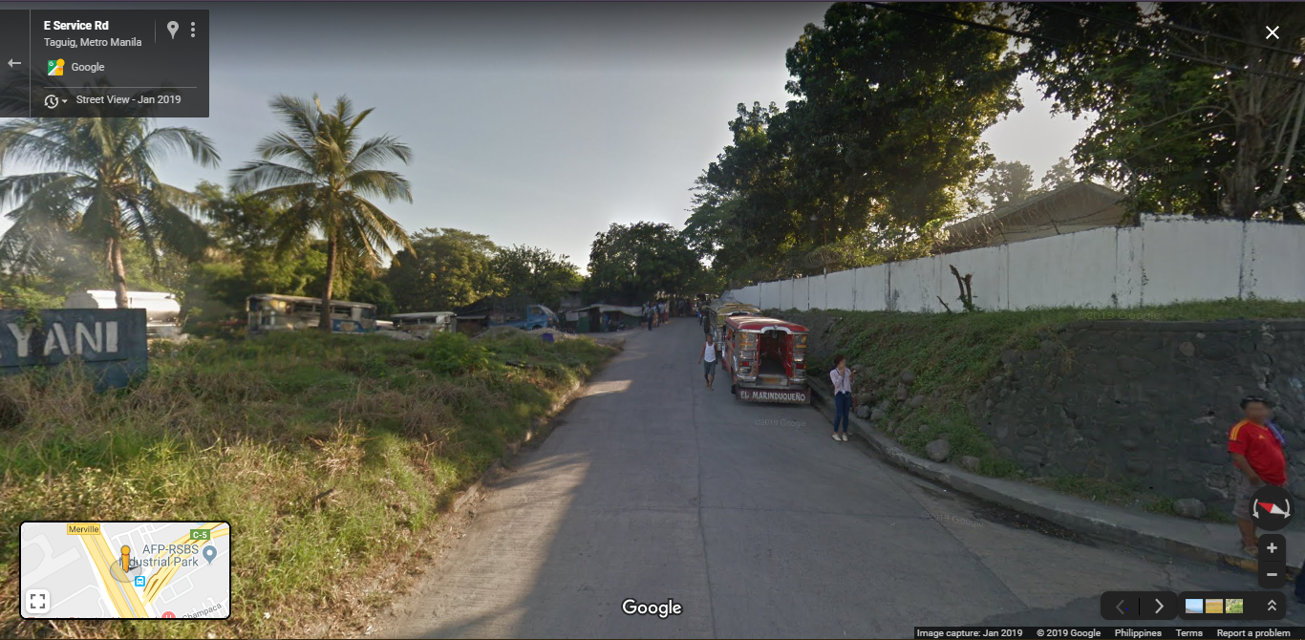

<https://www.google.com/maps/@14.5130119,121.0337531,153a,35y,319.45h,44.98t/data=!3m1!1e3>

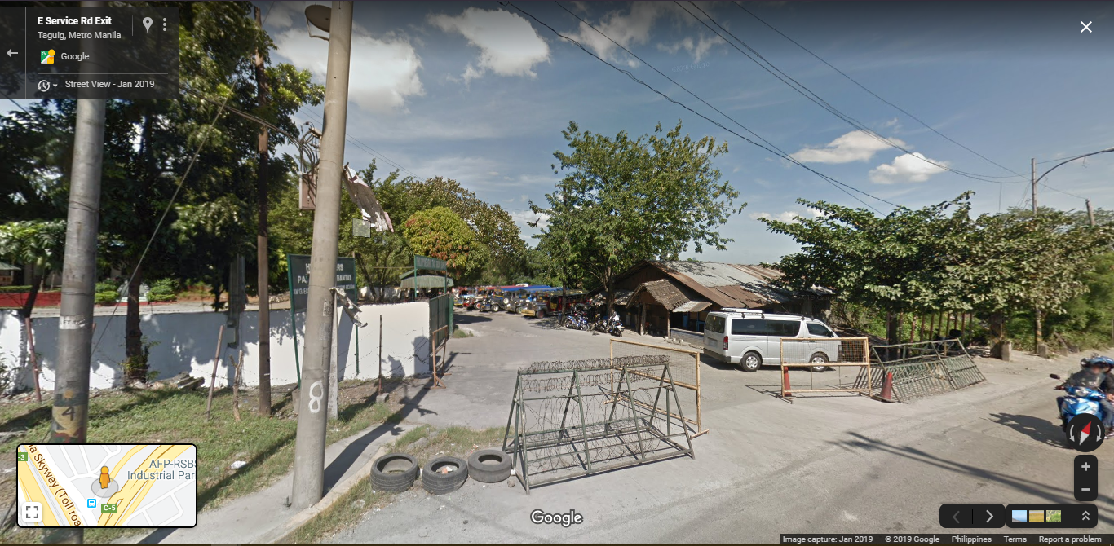

<https://www.google.com/maps/@14.5130119,121.0337531,153a,35y,319.45h,44.98t/data=!3m1!1e3>

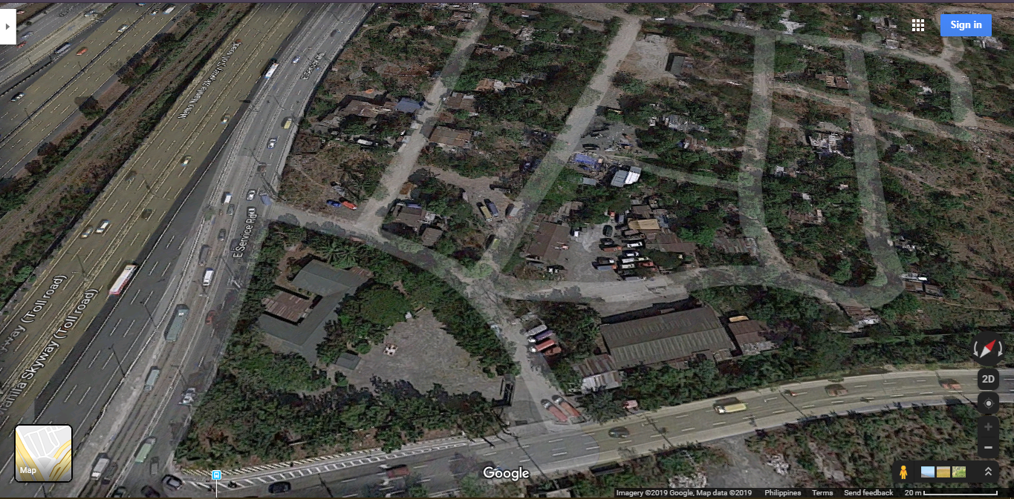

<https://www.google.com/maps/@14.5130119,121.0337531,153a,35y,319.45h,44.98t/data=!3m1!1e3>